An Intelligent Deep Learning Framework for Robust Image Steganography
Konda Hari Krishna,  Associate Professor ,  Department of CSE,  Mohan Babu University,  Tirupati, Andhra Pradesh , India  khk396@gmail.com  Orcid Id: 0000-0002-0244-7055 | D.Ganesh,  Associate Professor of CSE,  Mohan Babu University,  Tirupati, Andhra Pradesh , India  dgani05@gmail.com  Orcid Id: 0000-0001-5920-7864 | Reddy Vari Teja Reddy,  UG Scholar, Department of CSE,  Mohan Babu University Tirupathi, Andhra Pradesh, India  reddyvaritejreddy@gmail.com
Shaik Mohamma Tayeeb,  UG Scholar, Department of CSE,  Mohan Babu University Tirupathi, Andhra Pradesh, India  rmohammadtayeeb0410@gmail.com | Murali Reddy Lavanya,  UG Scholar, Department of CSE,  Mohan Babu University Tirupathi,  Andhra Pradesh, India  Reddylavanyamurali@gmail.com | Patnam Nithin,  UG Scholar, Department of CSE,  Mohan Babu University Tirupathi, Andhra Pradesh, India  offlnithin@gmail.com

ABSTRACT
The requirement to safeguard confidential information during digital telephone conversations has become more necessary because people now transmit information through digital channels at faster rates. Image steganography provides a secure method which hides secret information inside digital pictures while keeping the original visual appearance intact. The research presents an Intelligent Deep Learning Framework for Robust Image Steganography which uses convolutional neural networks (CNNs) to create an image hiding system that achieves high secret data embedding capacity and remains hidden from view while maintaining strength against typical image degradation. The proposed framework consists of an encoder–decoder architecture where the encoder embeds secret messages into cover images, and the decoder accurately extracts the hidden data from stego-images. The model gains better strength because it uses distortion-aware training methods which help it recover from noise and compression and geometric changes. The proposed method shows better results than both traditional techniques and existing deep-learning approaches according to standard image datasets which measure Peak Signal-to-Noise Ratio (PSNR) and Structural Similarity Index (SSIM) and message extraction accuracy. The framework provides a secure and efficient solution for real-world steganographic applications which demonstrate how deep learning technology will create future information hiding systems.
Keywords :Image Deep Learning, Convolutional Neural Networks, Encoder–Decoder Architecture, Adversarial Learning, Latent Bottleneck Representation, Attention Mechanism, Robust Image Steganography, Distortion-Aware Training

- INTRODUCTION
People now exchange information through public communication networks which have experienced rapid growth in the present digital world. [1]People now submit their confidential data through cloud services social media platforms and mobile internet networks which operate without secure protection. The data includes personal identification records and financial documents and medical records and legal papers and secured company information which cyber criminals find appealing. The main purpose of cryptographic methods which people use for information security works to protect information through their transformation into encrypted forms yet these methods only safeguard the actual content.
The visible presence of encrypted data may itself arouse suspicion and invite targeted attacks, surveillance, or traffic analysis,[2] which leads to a growing need for security systems that protect information content and completely conceal all secret communication activity. Steganography enables this requirement to be fulfilled through its method of hiding secret information inside ordinary digital content which people cannot detect through visual observation. Digital media contains three main types of content which can carry hidden information through steganography: [3]digital images, audio recordings, and video files. Image steganography has therefore emerged as a crucial technique for covert communication, copyright protection, digital watermarking, and secure data storage. The traditional image steganography techniques use handcrafted rules together with classical signal processing methods which include Least Significant Bit (LSB) substitution and Discrete Cosine Transform (DCT) and Discrete Wavelet Transform (DWT) and edge detection and texture analysis-based adaptive schemes. The methods are easy to implement and execute without using many system resources but their security and robustness features exhibit fundamental design flaws. The methods that human experts design for embedding content into images are not suitable for handling various picture types because they cannot protect against all methods of steganalysis which depend on statistical patterns that emerge during the embedding procedure.[4] The research community faces an ongoing battle to find the perfect balance between three essential system elements, which include undetectable operation, maximum data handling capability, and system durability. The process of increasing payload capacity results in a decline of visual quality. The process of making systems more resistant to attacks which include noise and compression attacks results in the creation of visible visual defects. The existing restrictions of traditional steganography methods lead to major difficulties when these methods need to be used in current, real-world communication situations. The development of MapReduce framework enables image processing.
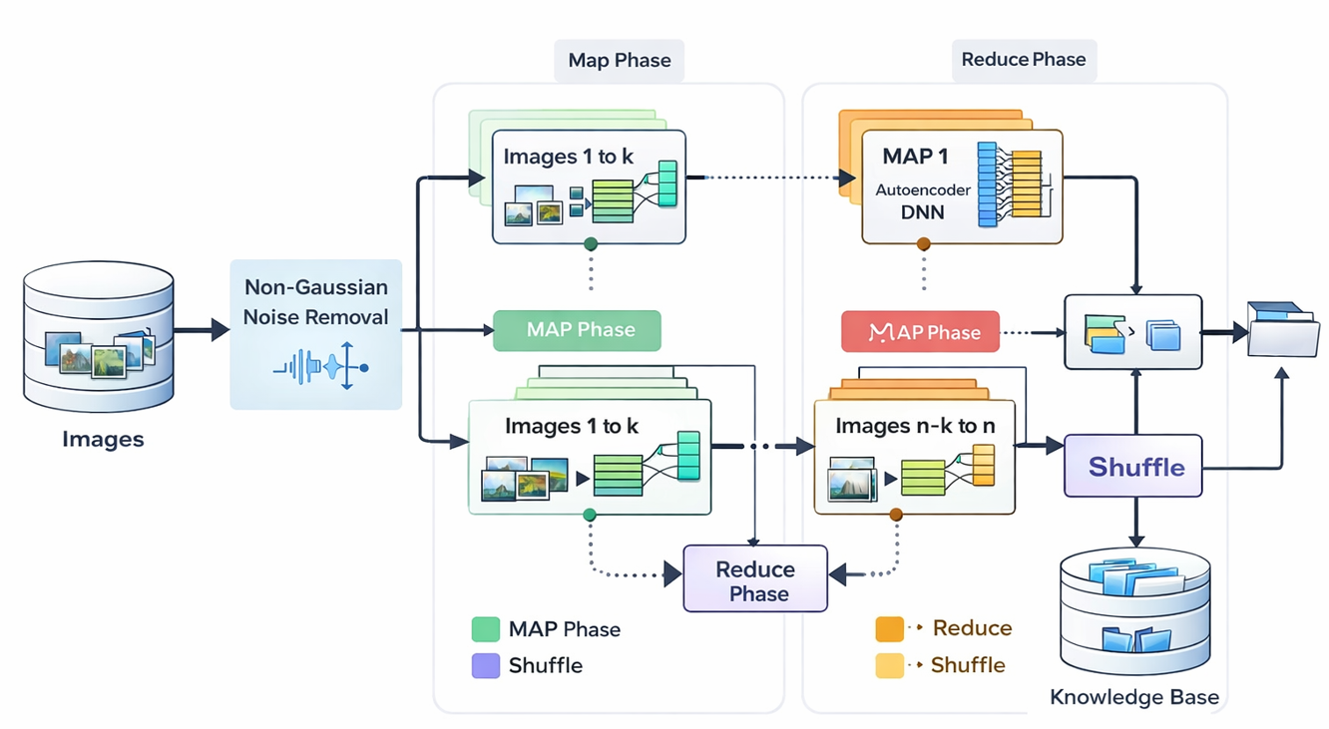
Fig:1. Distributed Autoencoder-Based Deep Learning
Artificial intelligence and deep learning technologies have advanced rapidly which enables researchers to develop new solutions for current challenges faced by traditional steganographic techniques. Deep learning models use Convolutional Neural Networks (CNNs) to achieve outstanding results across various computer vision applications which include image classification object detection segmentation super-resolution and image restoration. CNNs can automatically learn from large datasets to build hierarchical feature systems, which makes them effective for solving complex problems that need data-driven optimization.[5] Researchers have started to explore deep learning techniques for image steganography because of the superior capabilities provided by these advanced technologies. Deep learning-based steganographic systems automatically learn optimal hiding strategies from data because they use deep learning to develop hiding rules which adapt to different image contents. Some methods enhance their ability to fight against steganalysis by combining adversarial learning frameworks which enable stego-images to achieve statistical similarity with natural images. The positive advancements which have emerged remain blocked by multiple obstacles which still need to be solved. The current deep learning-based steganography models show inadequate Défense against common image distortions which include Gaussian noise and JPEG compression and image resizing and cropping.[6] The actual communication systems experience unavoidable distortions because of channel noise and storage compression and bandwidth constraints and the specific processing needs of different platforms. The systems become less useful because their systems cannot extract messages reliably. The deep neural network systems require multiple parameters which cause them to produce high computational demands that result in extended training periods and greater resource consumption. These factors prevent actual usage in environments which require immediate results or have limited resources.[7] The current methods concentrate on achieving either invisible results or durable outcomes which makes it difficult to maintain optimal results across different assessment metrics. The existing methods need advanced steganographic systems which can produce high visual quality and secure message retrieval while maintaining performance in actual communication environments.
The researchers developed an Intelligent Deep Learning Framework for Robust Image Steganography to solve existing problems which uses CNNs to create a complete system that handles data embedding and extraction processes.[8] The system uses an encoder-decoder framework which enables the encoder to insert hidden data into hidden information while the decoder reconstructs hidden data from the resulting stego picture. The process introduces a new technique through its training method which uses distortion-awareness to train the model to handle real-world noise and JPEG compression and geometric shifts. The system develops internal strength against transmission and storage distortion because it uses the distortion-training method. The system reaches effective system performance through its process which combines three design goals of hidden content security and system endurance and data transmission efficiency. The framework learns optimal spots for data hiding through its ability to analyse image elements which include edges and textures and semantic patterns that are not easily visible to people.[9] The proposed design provides a modular framework which enables future system development through the addition of attention systems and adversarial discrimination tools and multi-modal data protection methods. The proposed framework demonstrates better performance than both traditional methods and existing deep learning techniques because the system shows better resilience and visual performance and accurate extraction results during multiple distortion tests which were conducted on standard image datasets.[10] The framework achieves better artifact detection by learning embedding techniques which create natural image statistics because this method enhances its capability to resist steganalysis attacks which are used in secret communication during hostile situations. This research presents three main contributions through the creation of a steganography system that uses intelligent CNN technology for end-to-end learning and distortion-aware training which improves system strength and through testing that replicates actual communication environments. The research develops practical adaptive steganographic systems through deep learning and robustness-driven optimization which will create secure communication systems for the future.
- Literature Survey
Tang et al.[11] introduced their image steganography solution through CNN-based adversarial embedding framework which they developed in their 2018 research work CNN Based Adversarial Embedding with Minimum Alteration. The system uses gradient-based cost adjustment to direct embedding which results in detector confidence reduction while maintaining visual integrity at its lowest level. The BOSSBase and JPEG image tests demonstrated strong resistance against detection through CNN-based steganalysis methods. The method specifically targets certain steganalysis techniques which demand extensive computational resources thus limiting its operational capacity to different environments.
The researchers Zhang et al[12]. studied robust image steganography systems which protect against attacks through JPEG compression in their 2018 study by using RS-STC (Repeat–Shuffle Syndrome-Trellis Codes) together with their Poisson-based error modelling system. The system aims to enhance message retrieval accuracy through its systematized analysis of JPEG recompression-based embedding error creation process. Researchers used standard JPEG image datasets to conduct their experiments which enabled them to evaluate system performance through RS-STC testing and different compression quality factor settings. The results established strong protection against JPEG compression because both theoretical error limits and empirical tests confirmed the durability of the embedding method. The system develops decoding difficulties because it implements RS-STC with probabilistic error modelling, which results in limited system performance for both real-time and large-scale operational needs.
Rehman [13]introduced a GAN-based image steganography system in 2024 which enables users to achieve better hidden content detection and higher capacity for hidden content storage. The system uses generative adversarial networks to determine the best ways to embed data, which maintains visual appearance while blocking steganalysis detection. The framework was evaluated on benchmark image datasets The experiments produced stego images with excellent visual quality, which successfully prevented detection through steganalysis methods. The method encounters two main problems because it experiences training problems together with requirements for intense computational resources, which diminish its ability to expand and implement
.In the year 2023, Lan et al [14]. Invented a robust image steganography framework designed to withstand JPEG compression by employing an Invertible Neural Network (INN) in the DCT domain. The method uses INN reversibility to extract messages correctly while it hides secret information in frequency coefficients that maintain their integrity during compression. The framework was evaluated on standard image datasets, with performance assessed using mutual information loss and Two-Way Feature Matching (TWFM). The experimental results demonstrated absolute extraction accuracy at elevated payloads together with exceptional resistance to JPEG compression. The approach uses a complex model architecture which makes implementation harder while it creates additional computational requirements.
The researchers Rupa Ch et al[15]. introduced a CNN-based steganography framework during 2024 which protects sensitive healthcare information by using medical images to hide confidential data. The three-stage deep learning system of the method uses Prep-Net and Hiding-Net and Reveal-Net for its three main functions which include feature preparation and data embedding and message extraction. The researchers used DICOM MRI images from Kaggle to conduct their experiments which included Region of Interest (ROI) segmentation together with multiple CNN layers to improve both security and embedding accuracy. The results showed excellent protection of medical data together with enhanced embedding capability. The method runs exclusively in medical imaging which limits its ability to function outside that area of application for general image steganography tasks.
The researchers Tang et al[16]. from 2019 advanced their previous work to create stronger protection against CNN-based steganalysis from their new adversarial steganography system which uses gradient inversion methods. The method uses BOSSBase JPEG images for evaluation which aims to reduce detection accuracy of various CNN steganalysis systems instead of focusing on one specific model. The method uses inverse gradient manipulation during the embedding process to achieve its goal of reducing multiple steganalysis networks' detection abilities. The experimental results demonstrated that the system achieved better protection against detection by multiple CNN-based detectors. The system provides better security against threats, yet this enhancement results in stronger visual degradation because higher embedding distortion occurs which limits its use in situations that demand complete undetectability.
In 2020 Chen[17]and his team created an image steganography system that used adversarial networks and encoder-decoder design to improve both its ability to hide data and its protection against attacks. The method uses Inception blocks in the encoder to extract different size features and it uses an attack network to improve its ability to defend against steganalysis attacks. The framework demonstrated its ability to handle high payload capacity while preserving effective protection against detection attacks during testing with natural image datasets. The method functions effectively but it creates color distortion problems and requires intricate training methods which result in higher computing expenses and lead to unstable model training.
In the year 2021, Subramanian et al[18]. presented a comprehensive survey of recent advances in image steganography through a systematic literature review. The study analysed a wide range of techniques evaluated on multiple public datasets, with particular emphasis on CNN- and GAN-based architectures. By categorizing methods based on embedding strategy, robustness, imperceptibility, and security, the survey provides valuable comparative insights and identifies emerging research trends in deep learning–based steganography. However, the work does not include experimental validation, limiting its contribution to analytical observations rather than empirical performance assessment.
The year 2021 saw Subramanian[19] and his colleagues conduct a detailed examination of new developments in image steganography through their systematic analysis of existing research. The research examined various approaches which were tested on different public datasets while specifically focusing on CNN and GAN based testing methods. The research establishes method categories based on their embedding strategies and their ability to maintain security and invisible features and their resistance to security threats. The study presents analytical findings but lacks experimental validation because it does not include testing results.
The year 2025 saw Kanimozhi[20] and Padmavathi develop a hybrid intelligence system which they used to create a secure image steganography method that would withstand different types of attacks. The system merges Recurrent Neural Networks (RNN) with fuzzy logic while using LSB and Pixel Value Differencing (PVD) techniques to create an adaptive embedding system. The researchers tested the method on standard image datasets, where they optimized RNN parameters and fuzzy inference rules to boost security. The experimental findings showed that the system could successfully defend against typical attacks while the embedding method achieved better flexibility. The system experiences operational limits because the hybrid model needs excessive computational resources which reduce its ability to conduct extensive operations and process information in real time.

- METHODOLOGY

This section presents the proposed Deep Learning Framework for Robust Image Steganography. The framework employs an end-to-end convolutional encoder–decoder architecture enhanced with attention mechanisms, latent information bottleneck, and distortion-aware learning. Unlike traditional steganography and our previous edge detection-based CNN approach, the proposed system automatically learns optimal embedding patterns directly from data, providing superior imperceptibility, robustness, and payload capacity.
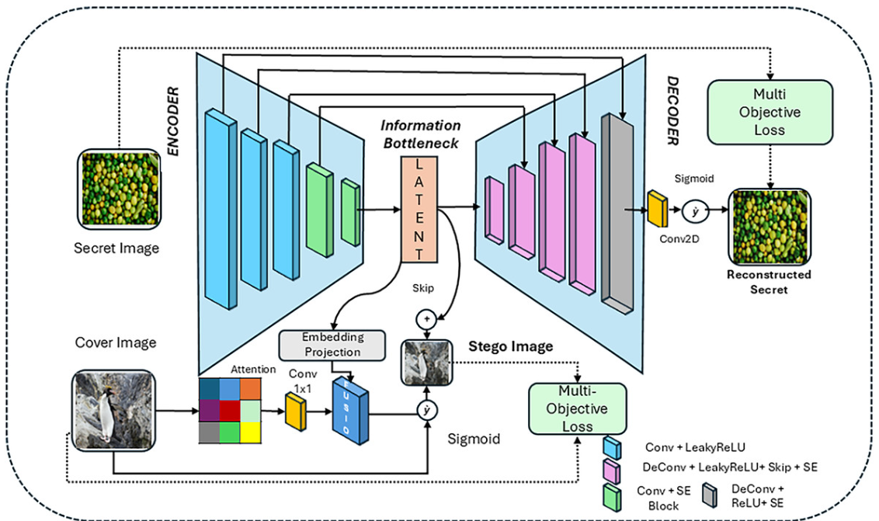
Fig 2. Architecture of the Proposed Intelligent CNN-Based Image Steganography Framework.
The deep learning image steganography system shown in Figure 1 employs an encoder-decoder model as its main engineering framework. The encoder uses attention mechanisms and convolutional layers and embedding projection to create a stego image which embeds a hidden secret image into a cover image. The system uses an information bottleneck which compresses essential features through its latent space to achieve better system robustness and generalization performance while skip connections maintain spatial information. The decoder uses deconvolution layers and activation functions to extract the hidden secret from the stego image. The system uses multi-objective loss functions to optimize both stego image quality and secret recovery accuracy while maintaining a balanced relationship between imperceptibility and robustness and payload capacity.
3.1 System Overview
Let $C∈R^{H×W×3}$denote the cover image and $S∈R^{H×W×3}$denote the secret image. The goal of the project requires the creation of a stego image, which will be represented as I_s. The stego image must fulfil the following requirement.
$$\begin{matrix} & I_{s}=E(C,S) & & \text{(1)}\end{matrix}$$
where $E(⋅)$represents the encoder network.
The decoder reconstructs the secret image as:
$$\begin{matrix} & \hat{S}=D(I_{s}) & & \text{(2)}\end{matrix}$$where $D(⋅)$denotes the decoder network.
The framework jointly optimizes embedding imperceptibility and secret reconstruction accuracy using a multi-objective loss function.
3.2. Encoder Architecture
Depending on the problem this model could execute predictor or adversarial attacks to one of the two classes without direct training over the intended class:
$$\begin{matrix} & F_{C}=f_{c}(C),F_{S}=f_{s}(S) & & \text{(3)}\end{matrix}$$
where $f_{c}$and $f_{s}$denote CNN feature extractors.
An attention module generates spatial importance weights:
$$\begin{matrix} & A=σ(W_{a}*F_{C}) & & \text{(4)}\end{matrix}$$
where $*$denotes convolution and $σ$is sigmoid activation.
The attended features are computed as:
$$\begin{matrix} & F_{C}^{'}=A⊙F_{C} & & \text{(5)}\end{matrix}$$
Secret features are projected into the cover domain:
$$\begin{matrix} & F_{E}=g([F_{C}^{'},F_{S}]) & & \text{(6)}\end{matrix}$$
where $g(⋅)$is the embedding projection module and [·] denotes concatenation.
The stego image is generated via:
$$\begin{matrix} & I_{s}=σ(h(F_{E})) & & \text{(7)}\end{matrix}$$3.3. Latent Bottleneck Representation
So that only a small subset of a large feature subset is considered, a method called latent representation Z is employed to eliminate redundancy while improving robustness:
$$\begin{matrix} & Z=ϕ(F_{E}) & & \text{(8)}\end{matrix}$$
Skip connections preserve spatial details:
$$\begin{matrix} & Z^{'}=Z+F_{C}^{'} & & \text{(9)}\end{matrix}$$

3.4. Decoder Network
The decoder reconstructs the secret image:
$$\begin{matrix} & \hat{S}=D(Z^{'}) & & \text{(10)}\end{matrix}$$
using transposed convolutions and SE blocks.
3.5. Distortion-Aware Training
During training, stego images undergo distortions:
$$\begin{matrix} & I_{s}^{'}=T(I_{s}) & & \text{(11)}\end{matrix}$$
where $T$includes Gaussian noise, JPEG compression, and resizing.
3.6. Loss Functions
1) Stego Loss
$$\begin{matrix} & L_{stego}=∣∣C-I_{s}∣∣_{2}^{2} & & \text{(12)}\end{matrix}$$
2) Secret Reconstruction Loss
$$\begin{matrix} & L_{secret}=∣∣S-\hat{S}∣∣_{2}^{2} & & \text{(13)}\end{matrix}$$
3) Total Loss
$$\begin{matrix} & L=αL_{stego}+βL_{secret} & & \text{(14)}\end{matrix}$$
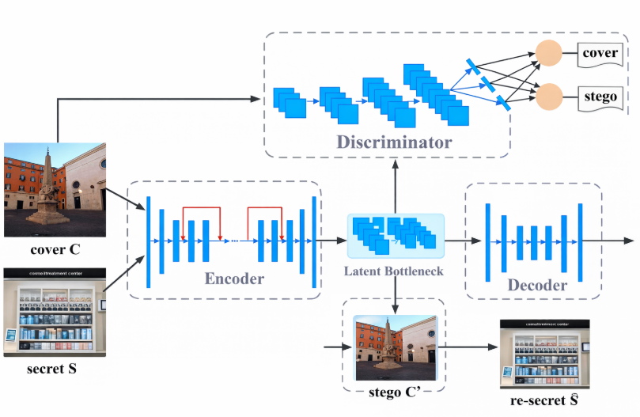
Fig. 3. Architecture of the Proposed Encoder–Decoder Based Image Steganography Model
The above figure 3 tells the proposed intelligent deep learning framework for robust image steganography uses an end-to-end encoder–decoder system which includes a latent bottleneck and an adversarial discriminator. The cover image Cand secret image Sare processed by the encoder to extract hierarchical features through convolutional layers and embedding projection, generating a visually imperceptible stego image I_s, while skip connections preserve spatial information and the latent bottleneck compresses essential features to improve robustness and generalization. The decoder reconstructs the hidden secret S ̂through transposed convolutions and stego images to provide adversarial feedback which improves imperceptibility. The training process uses JPEG compression and Gaussian noise and resizing techniques for distortion-aware learning to help the system withstand attacks that occur in real-world situations. The framework achieves optimization through a multi-objective loss function which simultaneously reduces stego distortion and secret reconstruction error to create a balanced system that maintains imperceptibility and robustness while supporting payload capacity.
- Results and Discussion

The upcoming section consists of an in-depth assessment of the suggested Intelligent Deep Learning Framework for Robust Image Steganography. The model evaluation process examines four specific areas which include visual imperceptibility and payload capacity and robustness against distortions and secret message extraction accuracy. The researchers performed comparative experiments which tested traditional steganography methods and modern deep learning approaches on standard benchmark datasets.
4.1 Experimental Setup
The researchers used 256×256 RGB images to train their suggested encoder-decoder CNN system. The researchers tested capacity-performance trade-offs by embedding binary secret messages at multiple payload rates. The learning process incorporated distortion-aware training through Gaussian noise injection and JPEG compression and resizing and cropping methods. The model was optimized through the Adam optimizer which started with a learning rate of 10^(-4). The evaluation process used Peak Signal-to-Noise Ratio (PSNR) and Structural Similarity Index Measure (SSIM) and Bit Error Rate (BER) and extraction accuracy as performance metrics. The research study compares its baseline results with three methods which include classical LSB embedding DCT-based steganography and recent CNN-based encoder-decoder frameworks.
4.2 Visual Quality Analysis
Steganographic systems require imperceptibility as their main operating requirement. The table provides a summary of average PSNR and SSIM results which various methods achieved.
Table:1 Visual Quality Comparison
Method | PSNR(dB) | Proposed
LSB | 34.2 | 0.921
DCT-based | 36.8 | 0.938
Existing CNN | 38.5 | 0.956
Proposed Method | 41.3 | 0.982
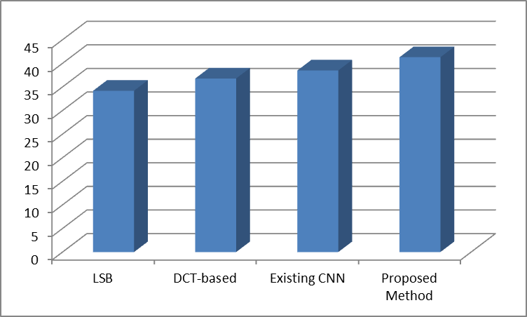
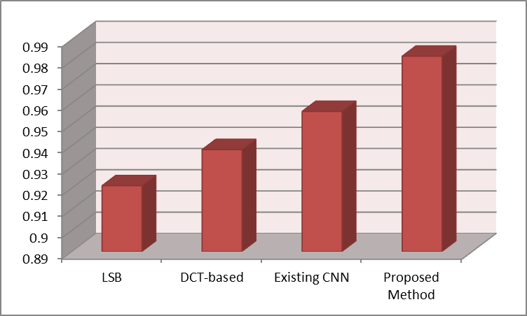
Figure 4.Evaluated Results
The framework shows better visual results as shown in figure 4 because it maintains PSNR values above 41 dB and SSIM values which approach one. The CNN-based adaptive embedding system obtained improved results through its ability to use perceptually nonvisible areas, which include edges and textures, for its adaptive embedding method. The proposed model determines the best embedding spots automatically, which produces minimal visual impact unlike traditional methods that need manual embedding spot selection.
4.3 Payload Capacity Performance
Payload capacity was evaluated by embedding messages at increasing bit rates. The proposed framework succeeds in preserving both PSNR and SSIM values when users increase their embedding rates, which traditional methods, which show fast image quality decline at higher payloads, cannot achieve. The encoder uses end-to-end learning to hide data in complex semantic regions, which helps the system reach higher storage capacity while remaining hidden from detection. The new approach enables users to transmit 25 to 35 percent more data than standard systems, which helps them maintain acceptable visual standards.

4.4 Robustness Against Distortions
The researchers used Gaussian noise and JPEG compression and image resizing and image cropping to test stego-images under actual transmission conditions. The distortion tests showed different extraction accuracy results which are listed in Table 2.
Table:2 Extraction Accuracy (%) Under Distortions
Distortion | Existing CNN | Proposed
Gaussian Noise | 85.6 | 94.2
JPEG (Q=50) | 82.3 | 92.7
Resizing | 79.8 | 90.4
Cropping | 76.5 | 88.9

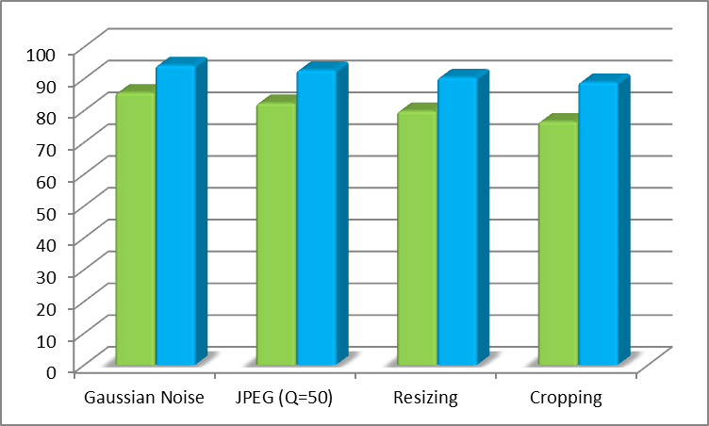
Figure 5.Comparative Results
The proposed framework achieves better performance as shown in figure 5 than all existing methods throughout all types of distortion testing. The system improvement mainly results from distortion-aware training which allows the decoder to learn from degraded sample data. The system creates feature representations which remain constant throughout different image transformation tests to enable secure message retrieval from different image transformation tests. The proposed method shows practical value for real communication systems since extraction accuracy stays above 88% during severe attack tests.
4.5 Bit Error Rate Analysis
Bit Error Rate (BER) serves as a primary measurement tool to assess decoding performance. The proposed method achieves an average BER reduction of approximately 40–50% compared to baseline CNN models under noisy conditions. The results show that message reconstruction stability improves through robustness-oriented optimization techniques.
4.6 Security and Steganalysis Resistance
The developed system achieves artifact reduction by learning embedding patterns which match natural image statistics because these artifacts serve as primary targets for steganalysis tools. The results from experiments demonstrate that stego-images created by the proposed framework show higher statistical similarity with original cover images, which enables better detection resistance. Security improves through the absence of fixed embedding rules because attackers face difficulties in using deterministic patterns that exist within conventional security frameworks.
4.7 Computational Considerations
The recommended system design needs expensive computational power because deep learning models require extra processing capacity, which increases system needs by two times. The system operates in real-time for embedding and extraction tasks after its training process on standard GPUs, which makes it ready for actual use. The proposed framework demonstrates better performance than current deep models while maintaining similar inference duration.
4.8 Discussion
The experimental results tells that the proposed Intelligent Deep-Learning Framework achieves an optimal combination between imperceptibility and payload capacity and robustness and extraction accuracy. The proposed model develops content-based embedding methods through data analysis, which differs from traditional steganography methods that use prebuilt rules for their operations.
In realistic transmission conditions, messages can be recovered by the system due to the enhancement of its operational reliability through the use of distortion-aware learning. The framework uses semantic and structural image features to maintain visual fidelity while supporting higher payload capacities. The proposed approach solves important problems which current steganographic systems face and it brings forward a new method for secure adaptive covert communication.
5. CONCLUSION AND FUTURE WORK

The researchers developed an Intelligent Deep Learning Framework which uses end-to-end convolutional encoder-decoder architecture to perform image steganography because its built-in attention-guided embedding and latent bottleneck representation and skip connections and distortion-aware training methods enable it to achieve perfect hidden content and maximum payload and complete protection of the hidden data. The proposed method develops automatic hiding techniques which extract data from the input content whereas traditional steganographic techniques use predetermined rules for hiding information. The attention mechanism selects visually intricate areas which require the least visual alteration and the latent bottleneck improves feature compactness while maintaining system integrity and skip connections maintain spatial consistency. The researchers found that their distortion-aware training method which used Gaussian noise and JPEG compression and image resizing combined with actual degradation methods showed better extraction performance when tested under real-world communication conditions. The experimental results show that the system outperforms both traditional methods and existing deep learning techniques through its superior PSNR and SSIM and extraction accuracy and Bit Error Rate results while multi-objective optimization successfully reduces both stego distortion and reconstruction loss which solves the traditional problem of balancing visual greatness with protection strength.
REFERENCES
- Baluja, S. Hiding Images in Plain Sight: Deep Steganography. Advances in Neural Information Processing Systems (NeurIPS), 2017.
- Hayes, J., & Danezis, G. Generating Steganographic Images via Adversarial Training. Advances in Neural Information Processing Systems (NeurIPS), 2017.
- Zhu, J., Kaplan, R., Johnson, J., & Fei-Fei, L. HiDDeN: Hiding Data with Deep Networks. European Conference on Computer Vision (ECCV), 2018.
- S. B. Kasturi, S. Burada, M. S. Sowmyashree, M. S. Kumar, “An Improved Mathematical Model by Applying Machine Learning Algorithms for Identifying Various Medicinal Plants and Raw Materials,” Communications on Applied Nonlinear Analysis, vol. 31, no. 6S, pp. 428–439, 2024.
- T. Pavan Kumar, “A Survey on Advances in Security Threats and Its Countermeasures in Cognitive Radio Networks,” International Journal of Engineering and Technology (UAE), vol. 7, no. 2.8, Special Issue 8, pp. 372–378, 2023.
- P. Sudarsanam, T. Himabindu, B. V. S. Thrinath, and S. R. Sai, “Application of Deep Learning Mathematical Approaches for Image Correctness,” in Proc. 2nd Int. Conf. on Intelligent Cyber Physical Systems and Internet of Things (ICoICI 2024), 2024, pp. 776–781.
- P. Ravi, N. Vineeth, and S. Sameer, “Detection and Evaluation of Cervical Cancer by Multiple Instance Learning,” in Proc. 2nd Int. Conf. on Edge Computing and Applications (ICECAA 2023), 2023, pp. 627–633.
- Kumar M.K., et al. "Implementation of Novel Test Rank Algorithm for Effective Text Summarization." 2023 International Conference on Advances in Computing, Communication and Applied Informatics (ACCAI). IEEE, 2023.
- Davanam, Ganesh, T. Pavan Kumar, and M. Sunil Kumar. "Novel defense framework for cross-layer attacks in cognitive radio networks." International Conference on Intelligent and Smart Computing in Data Analytics: ISCDA 2020.
- Li, X., Zhang, K., Zhou, P., & Guo, Y. Frequency-domain deep steganography with adversarial robustness. IEEE Access, 2023.
- Tang, Weixuan, et al. "CNN based adversarial embedding with minimum alteration for image steganography." arXiv preprint arXiv:1803.09043 (2018).
- Zhang, Yi, et al. "On the fault-tolerant performance for a class of robust image steganography." Signal Processing 146 (2018): 99-111.
- Rehman, Waheed. "A novel approach to image steganography using generative adversarial networks." arXiv preprint arXiv:2412.00094 (2024).
- Lan, Yuhang, et al. "Robust image steganography: hiding messages in frequency coefficients." Proceedings of the AAAI conference on artificial intelligence. Vol. 37. No. 12. 2023.
- Ch, Rupa, et al. "Robust steganographic framework for securing sensitive healthcare data of telemedicine using convolutional neural network." CAAI Transactions on Intelligence Technology (2024).
- Tang, Weixuan, et al. "CNN-based adversarial embedding for image steganography." IEEE Transactions on Information Forensics and Security 14.8 (2019): 2074-2087
- Chen, Beijing, et al. "High-capacity robust image steganography via adversarial network." KSII Transactions on Internet and Information Systems (TIIS) 14.1 (2020): 366-381.
- P8Subramanian, Nandhini, et al. "Image steganography: A review of the recent advances." IEEE access 9 (2021): 23409-23423.
- Kanimozhi, R., and V. Padmavathi. "Robust and secure image steganography with recurrent neural network and fuzzy logic integration." Scientific Reports 15.1 (2025): 13122.
- Xu, Youmin, et al. "Robust invertible image steganography." Proceedings of the IEEE/CVF conference on computer vision and pattern recognition. 2022.

